Contents

Rotation by and angle about axis 1

Negating $u$ and $θ$ 6

# Rotation by and angle about axis

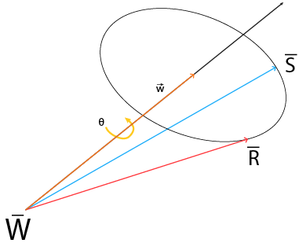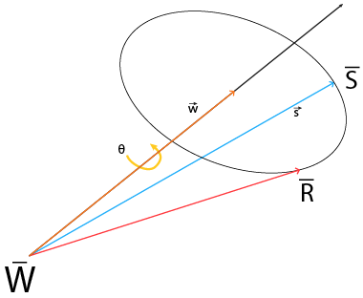

Imagine rotating about an axis $\vec{w}$, where the initial $\overline{R}$ is rotated anti-clockwise at an angle $θ$ to $\overline{S}$

The resulting point will be $\overline{S}=\overline{W}+ \vec{s}$

##### How to find $\vec{s}$

Rotation does not change the area/size of the object, when rotating on an axis, it is rotating on a plane.

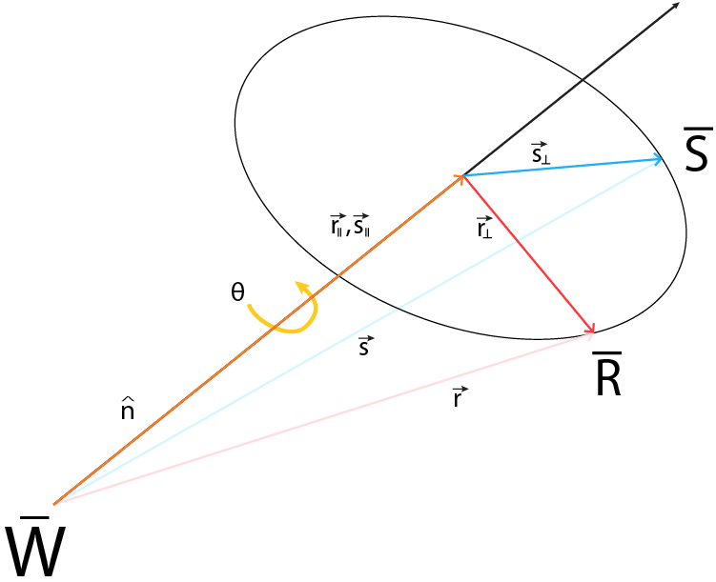

From the picture, we can compute these vectors

$\overline{R}- \overline{W}=\vec{r}$ (The initial vector)(Known)

$\overline{S}-\overline{W}= \vec{s}$ (The result vector)(Unknown)

$Normalize \overline{W}, =\hat{n}$ (Normalize the rotation axis) (Known)

${\vec{s}}_{ll}={\vec{r}}_{ll}=(\vec{r} .\hat{n})\hat{n}$ (The dot product, point $\overline{R} and \overline{S}$ lies on the same plane)

${\vec{r}}_{⊥}=\vec{r} -\left(\vec{r} .\hat{n}\right)\hat{n}$ (The dot product)

$\vec{s}= {\vec{r}}_{ll}+{\vec{s}}_{⊥}$ (The resulting vector)

##### How to find ${\vec{s}}_{⊥}$

The bird eye view of the plane looking down from the vector $\hat{n}.$ Vector $\hat{n}$ is point outwards and vector ${\vec{r}}_{⊥}$ is the “x” axis and the “y” axis can be computed by the cross product $\hat{n} X {\vec{r}}_{⊥}$.From the picture, we can deduce that ${\vec{s}}_{⊥}$ is a rotated vector from ${\vec{r}}_{⊥}$.

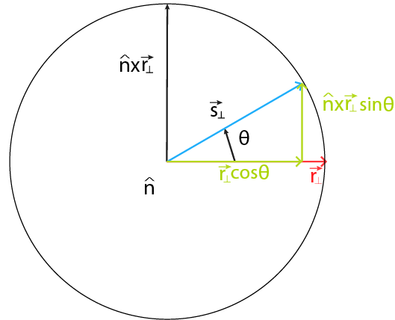

Therefore the “x” and “y” components of ${\vec{s}}_{⊥}$ is ${\vec{r}}_{⊥}cosθ$ and $( \hat{n} X {\vec{r}}_{⊥})sinθ$ respectively. The equation can be rewritten as:

$$\vec{s}= {\vec{r}}_{ll}+{\vec{s}}_{⊥}$$

$$\vec{s}= {\vec{r}}_{ll}+{\vec{r}}_{⊥}cosθ+ ( \hat{n} X {\vec{r}}_{⊥})sinθ$$

Rewrite the equation:

$${\vec{r}}_{ll}+{\vec{r}}_{⊥}cosθ+ ( \hat{n} X {\vec{r}}_{⊥})sinθ$$

$${\vec{r}}_{ll}+(\vec{r} -{\vec{r}}_{ll})cosθ+ ( \hat{n} X (\vec{r} -\left(\vec{r} .\hat{n}\right)\hat{n}))sinθ$$

$${\vec{r}}_{ll}+\vec{r}cosθ -{\vec{r}}_{ll}cosθ+ ( \hat{n} X \vec{r} -\hat{n} X \left(\vec{r} .\hat{n}\right)\hat{n})sinθ$$

$$\vec{r}cosθ +{\vec{r}}_{ll}-{\vec{r}}_{ll}cosθ+ ( \hat{n} X \vec{r} -0)sinθ$$

$$\vec{r}cosθ +{\vec{r}}_{ll}(1-cosθ)+ ( \hat{n} X \vec{r} )sinθ$$

$\vec{r}cosθ +\left(\vec{r} .\hat{n}\right)\hat{n}(1-cosθ)+ ( \hat{n} X \vec{r} )sinθ$

##### Tensor Product

Tensor product is used to rewrite an expression, so that it this expression can be converted to a matrix expression.

Example from the top:

$$Let \vec{t}=(\vec{r}.\hat{n})\hat{n}$$

$\vec{t}=\hat{n}\left(\vec{r}.\hat{n}\right)$ (Scalar multiplication is Commutative)

$\vec{t}=\hat{n}(\hat{n}.\vec{r})$ (Dot product is Commutative)

$\vec{t}=\hat{n}(n^{T}\vec{r})$ (Dot product rewritten as matrix multiplication)

$\vec{t}=({\hat{n}n}^{T})\vec{r}$ (Matrix multiplication is Commutative)

$\vec{t}=(\hat{n}⊗\hat{n})\vec{r}$ (It can be represent using symbols)

##### SKEW-Symmetrix Matrix

A normal cross product can be written as:

$$\hat{n} X \vec{r}= \left[\begin{aligned}nyrz-nzry \\ nzrx-nxrz \\ nxry-nyrx\end{aligned}\right]$$

We can rewrite the matrix as a skew matrix:

$$\hat{n} X \vec{r}= {\hat{n}}^{*} \vec{r}$$

$$\left[\begin{aligned}nyrz-nzry \\ nzrx-nxrz \\ nxry-nyrx\end{aligned}\right]=\left[\begin{aligned}0 \\ nz \\ -ny\end{aligned}\begin{aligned}-nz \\ 0 \\ nx\end{aligned}\begin{aligned}ny \\ -nx \\ 0\end{aligned}\right] \left[\begin{aligned}rx \\ ry \\ rz\end{aligned}\right]$$

A Skew matrix $\hat{n}$ transform a vector $\vec{r}$ into a vector, orthogonal to the plane of these two vector, basically cross product of two vectors.

##### Convert To MAtrix

With all the conversion in place we can convert to a rotation matrix. Sub vector $\vec{r}$ as an identity matrix

$$\vec{r}cosθ +\left(\vec{r} .\hat{n}\right)\hat{n}(1-cosθ)+ ( \hat{n} X \vec{r} )sinθ$$

$$\vec{r}cosθ +( {\hat{n}n}^{T})\vec{r} (1-cosθ)+ N^{*}\vec{r} sinθ$$

$$I cosθ+ \left(1-cosθ\right)\left[\begin{aligned}nx \\ ny \\ nz\end{aligned}\right]\left[nx ny nz\right]I+sinθ\left[\begin{aligned}0 \\ nz \\ -ny\end{aligned}\begin{aligned}-nz \\ 0 \\ nx\end{aligned}\begin{aligned}ny \\ -nx \\ 0\end{aligned}\right]I$$

$$\left[\begin{aligned}cosθ \\ 0 \\ 0 \\ 0\end{aligned}\begin{aligned}0 \\ cosθ \\ 0 \\ 0\end{aligned}\begin{aligned}0 \\ 0 \\ cosθ \\ 0\end{aligned}\begin{aligned}0 \\ 0 \\ 0 \\ 1\end{aligned}\right]+ \left(1-cosθ\right)\left[\begin{aligned}nx^{2} \\ nxny \\ nxnz \\ 0\end{aligned} \begin{aligned}nynx \\ ny \\ nynz \\ 0\end{aligned} \begin{aligned}nznx \\ nzny \\ nz^{2} \\ 0\end{aligned}\begin{aligned}0 \\ 0 \\ 0 \\ 1\end{aligned}\right]I+sinθ\left[\begin{aligned}0 \\ nz \\ -ny\end{aligned}\begin{aligned}-nz \\ 0 \\ nx\end{aligned}\begin{aligned}ny \\ -nx \\ 0\end{aligned}\right]I$$

Vector $\hat{n}$ is a priciple axis, where it can be any axis in the space.

$$\left[\begin{aligned}cosθ \\ 0 \\ 0 \\ 0\end{aligned}\begin{aligned}0 \\ cosθ \\ 0 \\ 0\end{aligned}\begin{aligned}0 \\ 0 \\ cosθ \\ 0\end{aligned}\begin{aligned}0 \\ 0 \\ 0 \\ 1\end{aligned}\right] + 1-cosθ\left[\begin{aligned}Rx^{2} \\ RxRy \\ RxRz \\ 0\end{aligned} \begin{aligned}RyRx \\ Ry^{2} \\ RyRz \\ 0\end{aligned} \begin{aligned}RzRx \\ RzRy \\ Rz^{2} \\ 0\end{aligned}\begin{aligned}0 \\ 0 \\ 0 \\ 1\end{aligned}\right] + sinθ\left[\begin{aligned}0 \\ Rz \\ -Ry \\ 0\end{aligned}\begin{aligned}-Rz \\ 0 \\ Rx \\ 0\end{aligned}\begin{aligned}Ry \\ -Rx \\ 0 \\ 0\end{aligned}\begin{aligned}0 \\ 0 \\ 0 \\ 1\end{aligned}\right]$$

$$\left[\begin{aligned}cosθ+Rx^{2}(1-cosθ) \\ RxRy\left(1-cosθ\right)+Rz(sinθ) \\ RxRz\left(1-cosθ\right)-Ry(sinθ) \\ 0\end{aligned}\begin{aligned}RyRx\left(1-cosθ\right)-Rz(sinθ) \\ cosθ+Ry^{2}(1-cosθ) \\ RyRz\left(1-cosθ\right)+Rx(sinθ) \\ 0\end{aligned}\begin{aligned}RxRz\left(1-cosθ\right)+Ry(sinθ) \\ RyRz\left(1-cosθ\right)-Rx(sinθ) \\ cosθ+Rz^{2}(1-cosθ) \\ 0\end{aligned}\begin{aligned}0 \\ 0 \\ 0 \\ 1\end{aligned}\right]$$

# Negating $\hat{u}$ and $θ$

If the polygon is not rotating, $\hat{u}$ will be a zero vector, likewise, $θ$ will be zero. The rotating matrix will result in an identity matrix.

$$\cos\left(0\right)=1$$

$$\sin\left(0\right)=0$$

$$\hat{u}= \hat{0}$$

$$\left[\begin{aligned}1+Rx^{2}\left(1-1\right) \\ RxRy\left(1-1\right)+Rz\left(0\right) \\ RxRz\left(1-1\right)-Ry\left(0\right) \\ 0\end{aligned}\begin{aligned}RyRx\left(1-1\right)-Rz\left(0\right) \\ 1+Ry^{2}\left(1-1\right) \\ RyRz\left(1-1\right)+Rx\left(0\right) \\ 0\end{aligned}\begin{aligned}RxRz\left(1-1\right)+Ry\left(0\right) \\ RyRz\left(1-1\right)-Rx\left(0\right) \\ 1+Rz^{2}(1-1) \\ 0\end{aligned}\begin{aligned}0 \\ 0 \\ 0 \\ 1\end{aligned}\right]=$$

$$I= \left[\begin{aligned}1 \\ 0 \\ 0 \\ 0\end{aligned}\begin{aligned}0 \\ 1 \\ 0 \\ 0\end{aligned}\begin{aligned}0 \\ 0 \\ 1 \\ 0\end{aligned}\begin{aligned}0 \\ 0 \\ 0 \\ 1\end{aligned}\right]$$